Modest Fashion Forum
Date: July 15, 2021
Time: 3:00 PM-Dubai Time

AlHuda Centre of Modest Fashion:
AlHuda-Center of Modest Fashion came into existence in 2019. Ever since its commencement, AlHuda Centre of Modest Fashion team is working devotedly and tirelessly to promote Modest Fashion around the world beyond religious misconceptions. Our purpose is to develop a global network of Modest Fashion and to educate and train people by conducting research & development, capacity building, events, publications and providing consultancy to fashion brands, in this regard so that we can normalize the concept of modest fashion for both men and women.
Modest Fashion Forum:
AlHuda Centre of Modest Fashion is pleased to hold Modest Fashion Forum on 15 July at 03:00 Pm-Dubai Time (GMT+4) with a global panel of speakers to promote modesty around the world. The session will be online and free of cost. In this Forum there will be a detailed discussion on Modest Fashion, how it was originated and now what is the scope of Modest Fashion.
Contents:
- Modest Fashion - Confident and Comfortable
- Beyond the Limits, Global & Digital Thinking on Modest Fashion
- Modest Fashion and its Global Growth.
- The Resurgence of Modest Fashion: Why Now?
- Sustainable Modest Fashion & it’s impact on the global Islamic Economy.
- Future of Fashion and why virtual fashion shows are relevant in our current times.
- Modest Fashion Culture in Russia and CIS.
- The Role of religion in consumer behavior.
- Realizing Modest Fashion Trends 2021 (spring-summer)
- The Role of AlHuda Centre of Modest Fashion in the promotion of Modesty.

Speakers Detail:
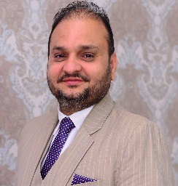
Muhammad Zubair
Chief Executive Officer
AlHuda Centre of Modest Fashion-UAE.

He is a Chief Executive officer of AlHuda Centre of Modest Fashion. He is also a Chief Executive officer of AlHuda CIBE and Halal Research Council. His overall academic career is outstanding with M.S in Islamic Banking and Finance, M.sc (Mass Communication), B.sc (Math, Stat and Economics) and with diversified knowledge of Islamic Banking and Finance. He is also PhD (Islamic Banking and Finance) Scholar. He has been serving the Islamic Banking and Finance industry for last 16 years with versatility in Islamic Banking & Financial Engineering, Modeling, Product Development, Shariah Advisory, Market Research and Gap Analysis. He is dedicatedly and tirelessly working for the promotion of Islamic Finance through Education, Research, Trainings and Conferences on global canvas. He is also a Chief Editor of a magazine on Islamic Banking and Finance “True Banking” which depicts his strategic vision in Islamic Finance. Muhammad Zubair Mughal has got ideal global recognition with multiple assignments of world repute organizations on Islamic Banking and Finance for “Research”, “Training”, “Advisory”, “Consultancy” and “Product development”.

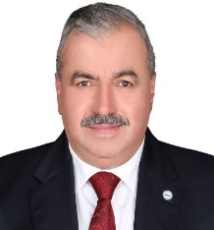
İhsan ÖVÜT
Secretary General of SMIIC

Mr. İhsan ÖVÜT was born in Malatya/Turkey in 1966 and completed primary, secondary and high school education in Malatya. In 1985, he started to study in the Department of International Relations of Faculty of Political Sciences of Ankara University and graduated from the college in 1989. Then, he began to work at the Turkish Standards Institution (TSE) at the Department of Bilateral and Multilateral Agreements. Following his successful tenure as the Director of several Directorates, İhsan ÖVÜT was appointed as the Head of Training Department of the TSE. While he was assuming his duties as the Head of Training Department he was elected as the Secretary General of Standards and Metrology Institute for Islamic Countries (SMIIC). During his term in SMIIC and under his leadership, various projects and tasks have been successfully accomplished including the restructuring of the Institute, revision of all internal regulations along with the founding Statute, formation of halal conformity assessment system, OIC Global Halal Quality Infrastructure, improving technical infrastructure of SMIIC as well as making SMIIC Technical Committees more active and more professional.


Aisha Nancy Novakovich
Chair Roots TV,
Founder of Modest Fashion Australia.

Aisha Nancy Novakovich is a Chair Roots TV. She is Co-designing film project for the New Museum of WA and Roots TV & Co-designing program for community Arts Network. She is also a Founder & Director of Modest Fashion Australia where she established and scaled social enterprise, created events and produced several fashion shows. She established a creative hub and co-working space for designers and entrepreneurs. She also worked with Getty Images and Canon Australia. She is also an Advisor at Western Australian Police that is Multicultural Women’s Advisory Group. Previously she worked as a Director of Langford Islamic College Board, Marketing and Communication officer at Essential Personnel, Community officer at Muslim Women’s Support Centre. She is also awarded with Premier’s Multicultural Ambassador Award, Prime Minister’s Centenary Medal and many others.

Joean “Iman” Montayre
Modest Fashion Advocate,
Director of MFDP, Philippines.
Joean “Iman” Montayre is a Modest Fashion Advocate/Fashion Designers/Journalist/Entrepreneur. Founder and Creative Director of MFDP; a platform dedicated for modest fashion- the first Modest Fashion movement in the Philippines. Multi-verse designer with more than 20 years’ experience in different fields including fashion haute couture and prêt-à-porter, furniture and home décor, jewelry, footwear, bags and textiles. A serial entrepreneur in RTW clothing and haute couture bridal wear, food technology and events organizing. Autodidactic and constantly loves to learn new things, an advocate of modest fashion who inspires others to wear hijab.

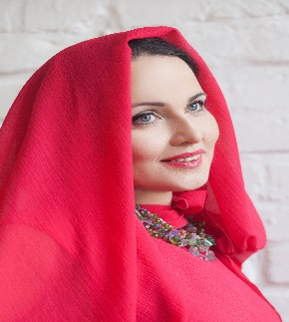
Dilyara Sadrieva
Co-founder Modest Russia,
Director of Modest Fashion Council, Russia & CIS.

She is Modest Fashion Researcher, expert, analyst, modest fashion brands & designers mentor/public speaker. She is Co-founder of Modest Russia & Council of Modest Fashion, Russia & CIS Director. Consulting, lecturing about modest fashion for mainstream and modest fashion industry
Participant and speaker at key global modest fashion events.
Constant guest and for all Modest fashion weeks, One of pioneers and one of the most influential persons in Russia Modest fashion industry. For many years she has been advocate, enthusiast for Modest fashion doing her best to establish and develop the industry, educating and lecturing about Modest fashion business and its peculiarities.

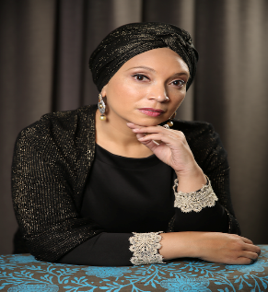
Roshan Isaacs
Managing Director/Editor in Chief Style Africa
Director Council of Modest Fashion Africa.

Roshan Isaacs is a Modest Fashion advocate who travels the world’s fashion events, curating for international fashion shows and films, speaker at international economic forums, featured in numerous magazines, appeared in many talk shows; being the Regional Director of Africa Modest Fashion Council, the creator and the Editor- in- Chief of Style Africa; the Managing Director of NoMemo accessories; former General Station Manager at e.tv (Pty) Ltd; the host of her self- run Podcast and Vlog series called “On My Radar” which features her interviews with leading modest fashion figures from around the world. Roshan Isaacs has enjoyed an enormously successful career filled with several significant accomplishments. She is an award winning recipient of the CEO’s Most Influential Women in Africa for the media sector, a finalist in the Margaret Hirsch Business Woman of the Year Award for her role in the modest fashion industry, and a bronze award winner for her poetry recognized by the International Society of Poets.
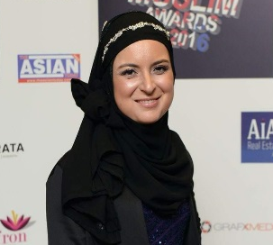

Hajra Khan
Ethical Fashion Consultant at Torino Fashion Match
Journalist & Presenter of Islam Channel, United Kingdom.

She is a skilled Special Projects Manager and have worked freelance in fashion consultancy with Ethical SME’s. Networking with and connecting B2B in the Modest business and fashion sector are part of my consultancy. Pre-Covid, she also informed businesses through workshops on the benefits of inclusivity of Islamic consumerism on the wider Global Economy. She is passionate about the Arts, politics, climate change, ecology and am privileged to explore this field through my Writing, Radio and TV work. She thrives on performing to an audience and being able to voice her opinion. Working as a presenter for a lifestyle show on the Islam Channel, Script Editor for an all-female super hero’s comedy and contributing to BBC Asian Network Radio has given her this opportunity.
She write for Muslimgirl.com magazine, The Islamic Fashion Design Council and run a blog about her various activities. She also has researched for production company, Tearaway Films. Co. UK on rise and impact of Modest Fashion on mainstream fashion.
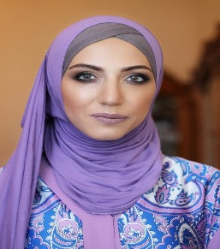
Farida Efendi
Director-Council of Modest Fashion Azerbaijan
Creator and Founder of Hijab Queen brand
Creator and Founder of HQS Events

Farida Efendi Graduated the Faculty International Relations and International Law of Baku State University in Azerbaijan. She is a Director of Modest Fashion Council-Azerbaijan. She is also a Founder of Hijab Queen Brand & HQS Events. Hijab Queen is not only a product but also a producer of other local designers. Hijab Queen is the representatives of the brands of Azerbaijani designers in the hijab industry.
Thus, having a wide audience not only in Azerbaijan, they are trying to show all countries of the world what talented designers they have. Hijab Queen is a Council of Modest Fashion Azerbaijan. She Was engaged in the production of exclusive handmade scarves made of 100% pure silk and natural dyes. Took part in Dubai Modest Fashion Week as a designer, Council of modest Fashion and as an Agent, representing 5 local Modest Fashion brands in the international Area. Organize Kids Festival (more than 50 Modest Fashion brands).

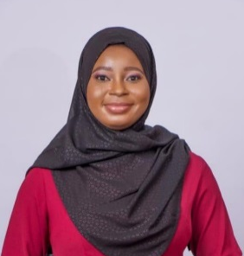
Adeosun Rukayat
Founder of “Pearls by Ray” Brand

Adeosun Rukayat is a fashion entrepreneur with 7years experience in fashion designing and garment construction. She’s passionate about empowering Muslim women through her clothing line “Pearls by Ray” that currently operates in Nigeria. She’s a Graduate of Biochemistry and has worked in the pharmaceutical field. As the founder of “Pearls by Ray” she’s a certified business administrator. She’s a leader who ensures relationship strengthening between staff and management who has successfully distinguished her brand from others with her creativity. She’s reliable, trustworthy and always strive for excellence.

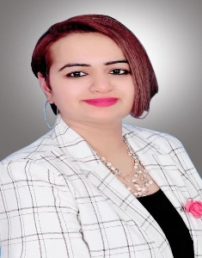
Meenu Prasad
Fashion Educationist
Principal-Istituto di Moda Burgo Qatar

Meenu Prasad, is well qualified fashion educationist and fashion designer with more than 10 years of experience in fashion industry. She is fashion design graduate, and studied from the most reputed fashion school of India, National institute of Fashion Technology. She began her career working with one of the leading buying house at Paris, Ana sui as fashion designer and senior merchandiser, later she moved on working with popular international clothing brands like Zara, Ted Baker, Debenhams U.K., Tommy Hilfiger etc. She wrote many Fashion Design assessments (Pearson BTEC HNC/HND) for Nottingham Trent University, U.K. which was catered by NILA, Gurgaon (India). She has been persistent Fashion speaker since last few editions at Heya Arabian Fashion Exhibition Doha, Qatar and conducted many valuable fashion workshops on concepts like Haute couture draping, visual merchandising etc. Moreover, she also Judged many international Fashion contests like Fashion Beauty pageant hosted by Indian woman association Doha, Qatar, design your dreams campaign by Gulf times, Russian international fashion festival hosted by Russia etc. Recently is being selected as Finalist in Mrs. India 2020 Queen of substance contest. she is currently looking forward to attend final rounds soon.

Registration Form
Modest Fashion Forum
Date: July 15, 2021

Please complete and return by e-mail, regular mail or fax.
Please note that the name and title you give here will be printed on participants’ list and on certificates.

Participant Information

Title: _____________
First name: _ _______________________________Last name: __ _______________________________
Organization: ____________________ Designation: __________________________________________
Address: _____________________________________________________________________________
City: __ _______________________________Country: ____ ___________________________________
Telephone: _____________________Cell: __________________________________________________
Official email id: _______________________ Personal E-mail: _______________________________

